Second Grade School Supply List

1 standard sized backpack  (16 in)  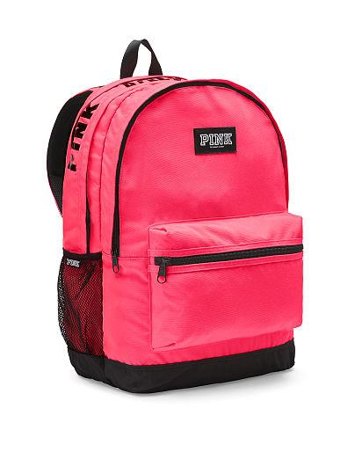 | 3 Mead primary composition books for grades K-2  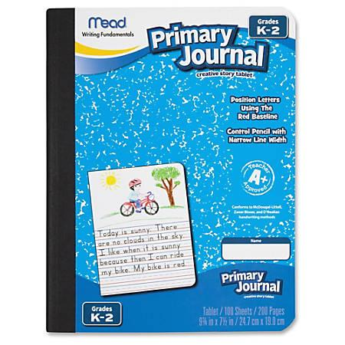 | 2 zippered pencil pouches  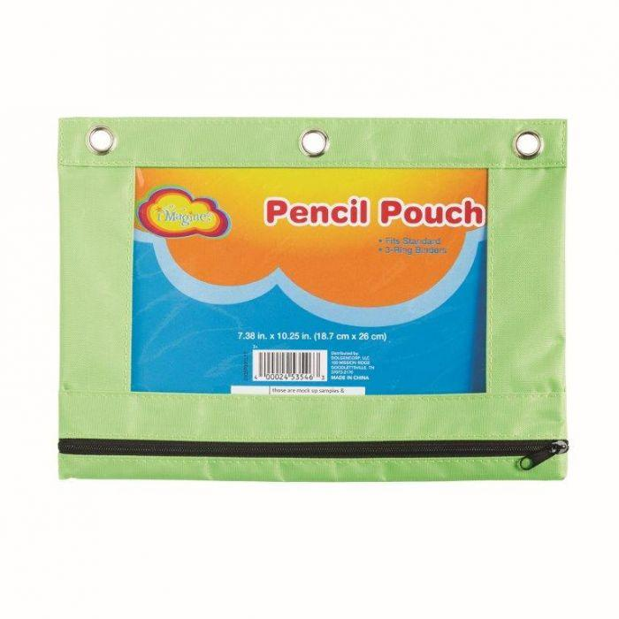 | 2 packs of Dixon Ticonderoga #2 SHARPENED pencils  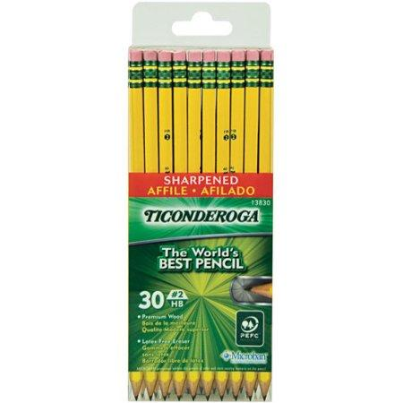
1 box of (12) count Crayola colored pencils  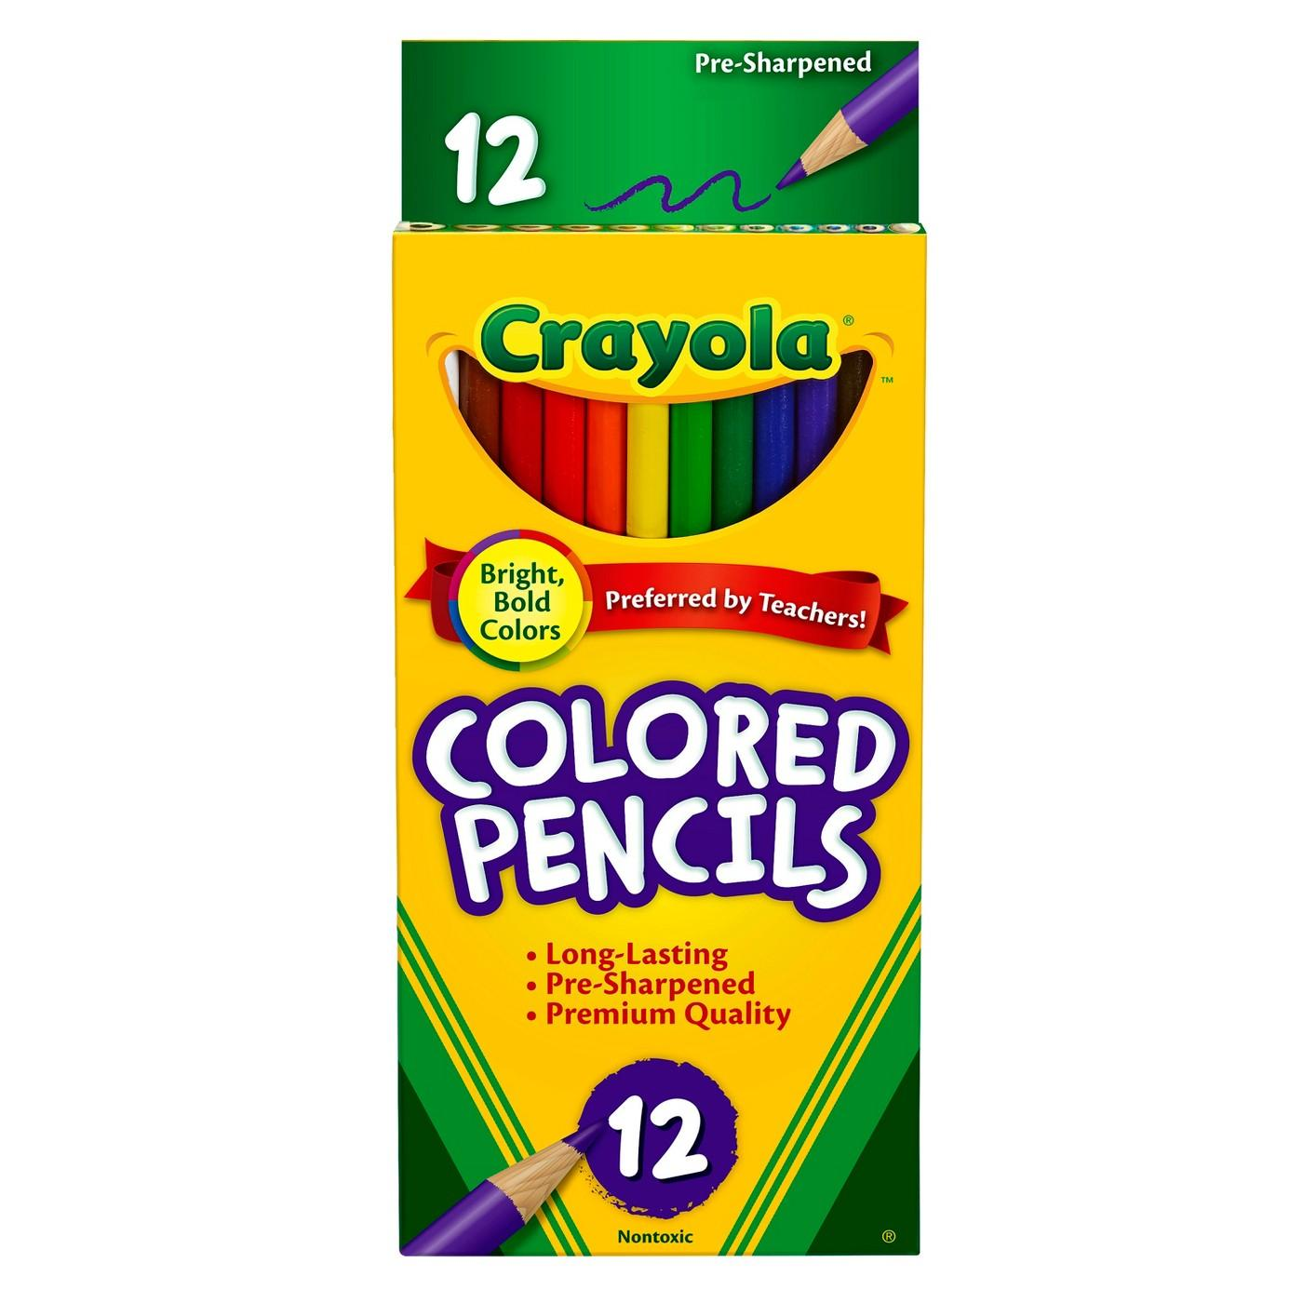 | 1 pack of (24) count  crayola crayons  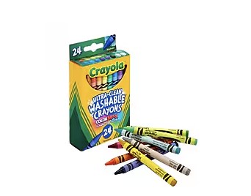 | 1 pack of pencil top erasers  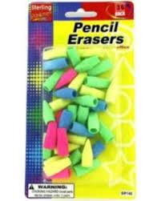 | 1 12 inch standard  ruler  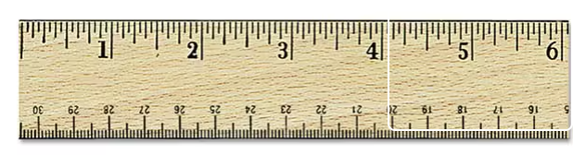
1 pack of Expo dry-erase markers with built-in cap eraser  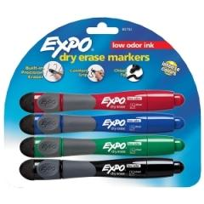 | 1 pack of neon highlighters  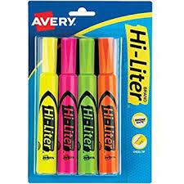 | 4 glue sticks  (no glitter glue)  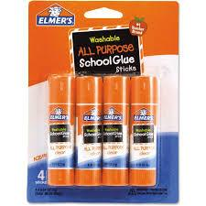 | 1 pair of rounded tip child size scissors  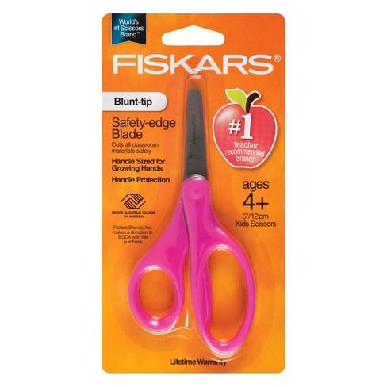
2 poly folders with pockets and a plastic cover on the front  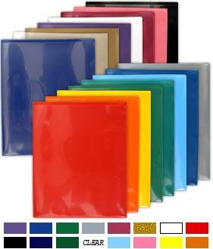 | 1 pair of earbuds or headphones  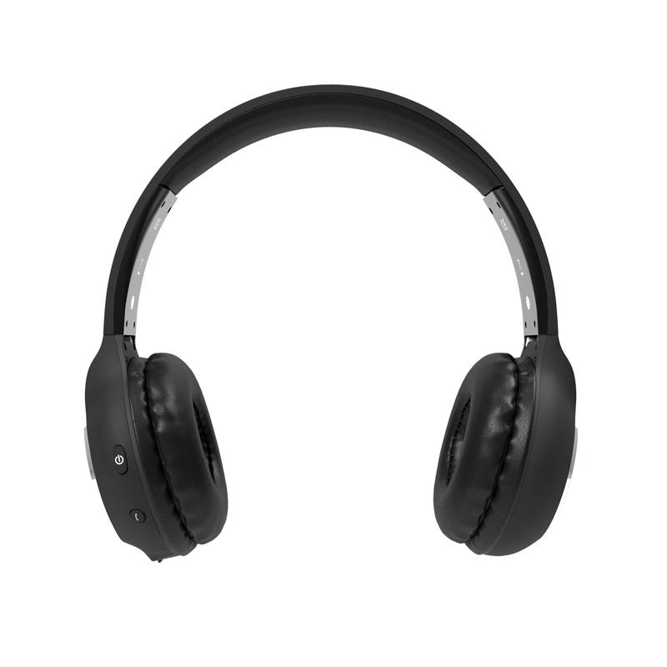 | 1 box of facial tissue  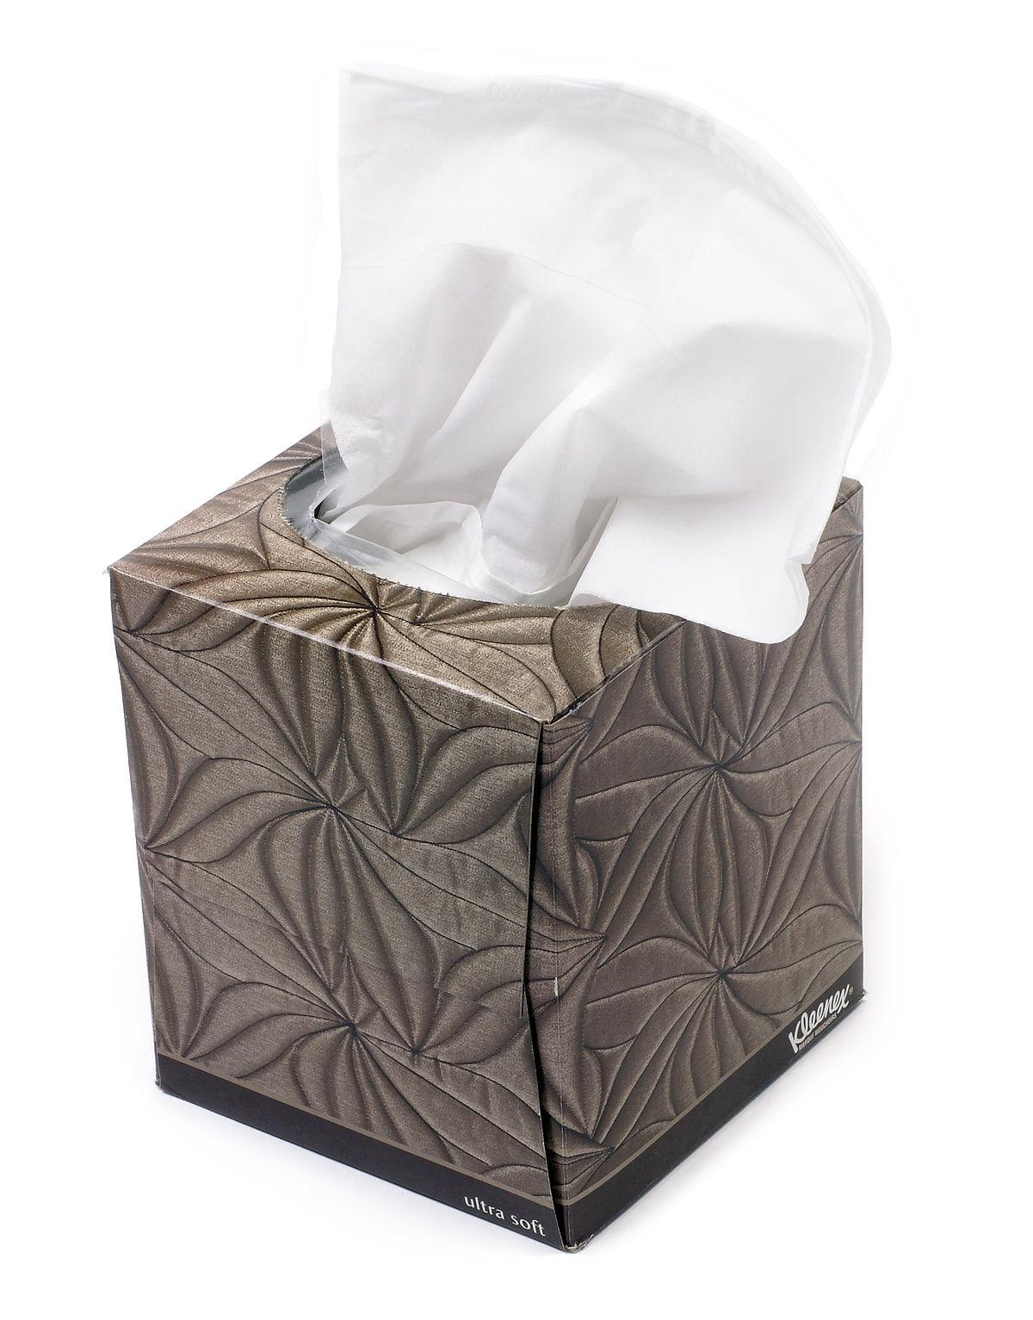 | 1 container of Lysol disinfectant wipes  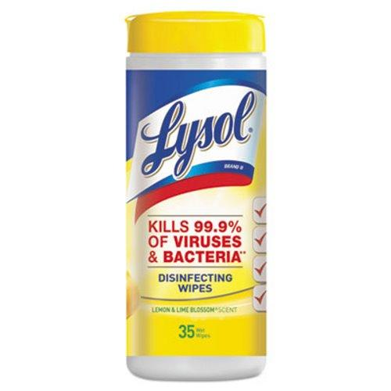
3 reams of white copy paper  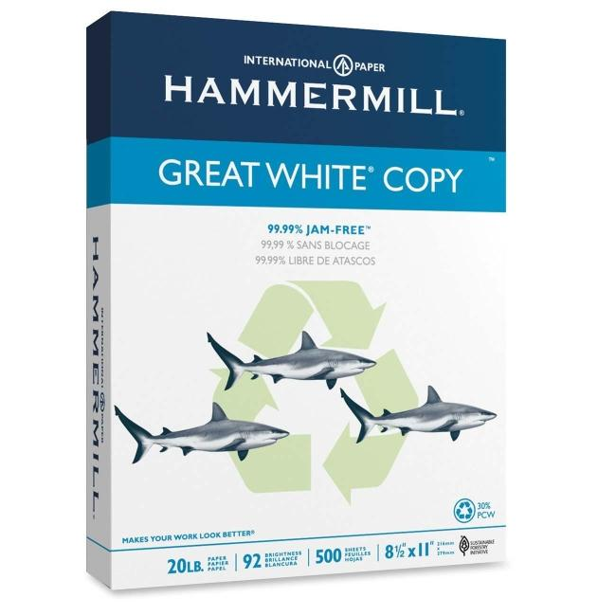 | 1 bottle of hand sanitizer  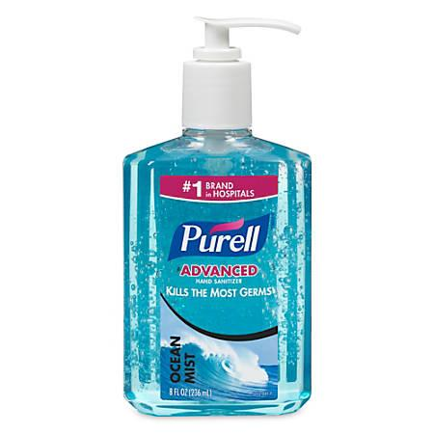 | 1 box of gallon sized Ziploc bags  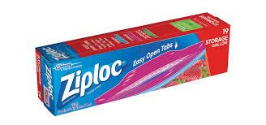 | 1 roll of paper towels  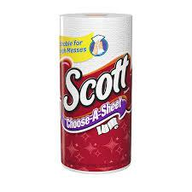
Please label each item with your child’s name*
(Do not send pencil sharpeners, mechanical pencils or pens)

