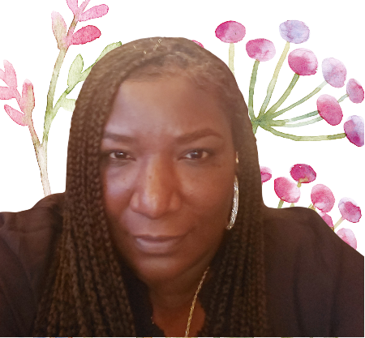

Dear Parents & Guardians,

My name is Ms. Chiquita and I am excited to inform you the I will be your child’s teaching for the upcoming school year. I have worked as a paraprofessional at Emlen Elementary for many years and I recently graduated with my Bachelors from College Unbound. This Fall, I will be attending Western Governors University for my Masters in Special Education.

I am dedicated to creating a nurturing and structured environment that supports each student's unique strengths and needs. My teaching philosophy centers on the belief that every child can thrive when provided with individualized support, consistency, and a compassionate community.

I am truly excited to embark on this journey with your child and to celebrate their achievements throughout the year. Together, we can create a positive and enriching educational experience.

**Room 208 Supply List**

* **Change of clothes (including underwear)**
* **Disinfectant wipes**
* **Headphones**
* **Gloves**
* **Baby Wipes (if needed)**
* **Pull – Ups (if needed)**
* **Pencil Case**
* **Paper Towels**