Supply List for Kindergarten

1 Primary writing journal (picture area up top/writing area below)
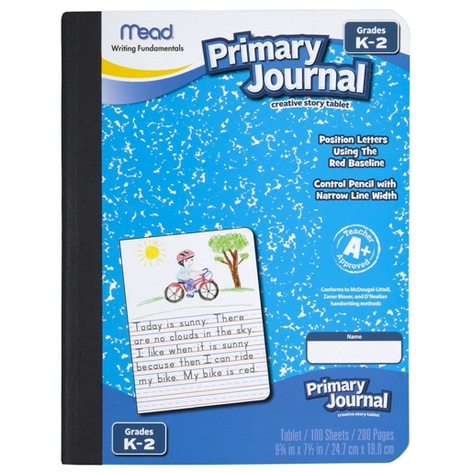
24 crayons

2 packs of index cards

beginner (fat) pencils

