THIRD GRADE SUPPLY LIST
2017-2018
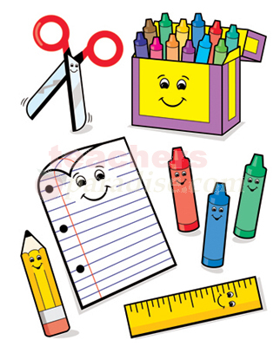
- 8 Black and White Composition Books
- 1 Pack of 24 pencils
- 2 red pens
- 1 pencil sharpener
- 2 packs of loose-leaf paper
- 1 pack of colored pencils
- 1 pack of Crayola markers
- 2 boxes of 24 Crayola crayons
- 1 pencil case
- 4 sturdy (Plastic Folders) 1 red 1 blue 1 green 1 yellow
- 2 dry erase markers
- 1 pack of Copy Paper
- 1 box of tissues
- 1 container of Clorox wipes
- 1 bottle of hand sanitizer

